
Year 7 Science: Ecosystems Name: ___________________________

 | Which of these human activities would have a negative impact on a natural environment.  A Clearing forests and replacing them with exotic trees  B Removing grazing cattle from a natural woodland  C Replanting eucalypt trees  D Reintroducing koalas into eucalypt forests. | D | 1
 | A habitat is:  - a place where an organism lives.  - an ecosystem.  - a group of competitors.  - the way an organism behaves. | A | 1
 | Which of the following is not an abiotic factor?  - Tree  - Water  - Light  - Temperature | A | 1
 | Which of these human activities has a positive effect on food webs.  A Opening up an area of bushland for recreational activities  B Removing introduced predators from an area  C Overfishing particular fish species causing a decline in numbers  D Introducing exotic species, such as rabbits and foxes | B | 1
 | All animals are:  - producers.  - consumers.  - carnivores.  - decomposers. | B | 1
 | Plants are examples of:  - producers.  - consumers.  - carnivores.  - decomposers. | A | 1
 | In the food chain below, which organism is the third-order consumer?  Grass  grasshopper  frog  snake  - Grass  - Grasshopper  - Frog  - Snake | D | 1
 | Bacteria and fungi belong to an ecosystem group called:  - composers.  - decomposers.  - plants.  - herbivores. | B | 1
 | As you move up the food web:  - the number of organisms increases.  - the number of organisms decreases.  - the number of organisms stays the same, but the size of each gets bigger.  - the number of organisms stays the same, but the size of each gets smaller. | B | 1
 | As energy flows through a food web:  - some of it is destroyed.  - all of it is eventually destroyed.  - some is lost to the environment.  - it is divided equally between each type of organism. | C | 1
 | The ultimate source of energy for all the organisms in a food web.  A Soil for providing essential minerals  B Water to prevent dehydration  C Green plants for photosynthesis  D The Sun for providing light | D | 3
 | Which of the following are not decomposers?  - Fungi  - Mould  - Crustaceans  - Bacteria | C | 1
 | Which of the following is not an introduced species?  - Wallaby  - North Pacific sea star  - Cane toad  - Rabbit | B | 1
 | The breakdown of the remains of dead organisms on and below the Earth’s surface is largely the responsibility of:  - consumers.  - decomposers.  - producers.  - scavengers. | B | 1
 | Which of the following terms is best used to mean ‘close to extinction’?  - Rare  - Vulnerable  - Endangered  - Suspect | C | 1
 | Give a single word to describe something made up of living and non-living things that interact with each other. | Ecosystem | 1
 | Give a single word to describe organisms that eat the same sort of food as each other. | Competitors | 1
 | On the following pyramid, label each level using the following words:  carnivores, producers, herbivores.  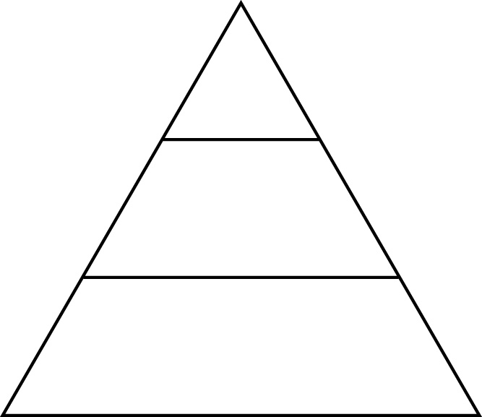 | Place producers on the bottom level, herbivores in the middle and carnivores at the top. | 3
 | Complete the missing part of each of the following words to form three different groups of animals. Explain what each word means.  - H………ivore  - C………ivore  - O………ivore | - Herbivore — eats plants  - Carnivore — eats animals  - Omnivore — eats both plants and animals | 6
 | Draw a simple food web involving the following organisms:  grass, worm, small bird, blue-tongue lizard, dingo. | 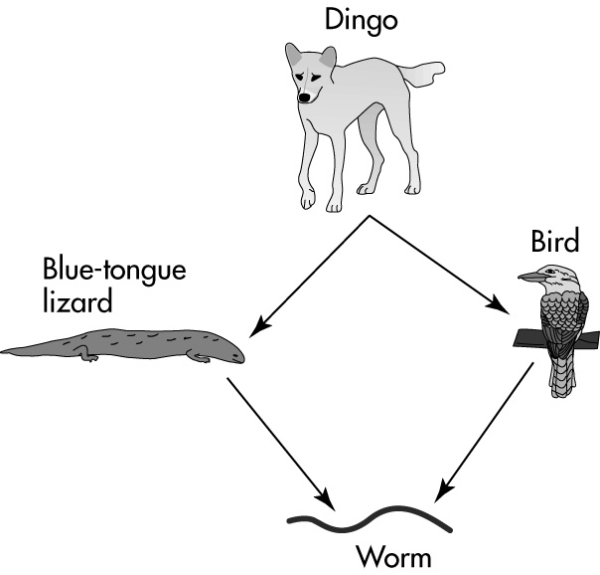 | 4
 | The diagram represents a food web in a freshwater lake.  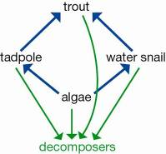  a What would be the effect on the population of water snails if the trout were fished out of the lake by very keen fishermen.  b Explain your answer. | a The water snail population would increase.  b Once the trout were removed from this food web, there would be no predators left to eat the water snails. | 3
 | Describe these terms by matching them with the correct definition: habitat, biosphere, ecosystem, environment.  a A particular area in which a group of organisms live, interacting with one another and with their non-living surroundings.  b The place where an animal or plant lives at a particular time.  c A combination of all of the living and non-living factors that an organism is subject to in the place where it lives.  d The place where all life exists. It consists of the Earth and its atmosphere. | A ecosystem  b habitat  c environment  d biosphere | 4
 | The diagram below shows a small part of a forest food web. Which of the organisms in the food web are:  - first-order consumers?  - third-order consumers?  - producers?  - decomposers?  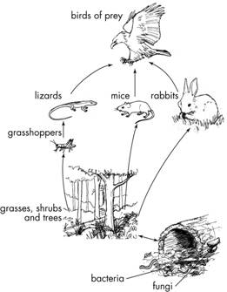 | - Grasshoppers, mice and rabbits  - Birds of prey  - Grasses, trees and shrubs  - Fungi and bacteria | 4
 | Use your knowledge and the food chain below to answer the following questions.  Grass → grasshopper → frog → snake → kookaburra  a Classify the organisms in this food chain as producers and consumers.  b Explain why producers and consumers are so named. | a Producers: grass  Consumers: grasshopper, frog, snake, kookaburra  b Producers are the organisms that use the Sun’s energy to produce or make energy-rich compounds. Consumers are the organisms that consume or eat other organisms, either producers or other consumers. | 3
 | Identify the food chain that is part of this food web.  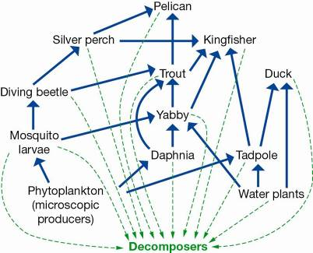  A Phytoplankton → daphnia → trout → duck → decomposers  B Water plant → tadpole → trout → kingfisher → decomposers  C Phytoplankton → mosquito larvae → yabby → silver perch → pelican → decomposers  D Water plant → yabby → trout → kingfisher → decomposers | D | 1
 | Study the diagram shown, which represents a food web in a freshwater creek.  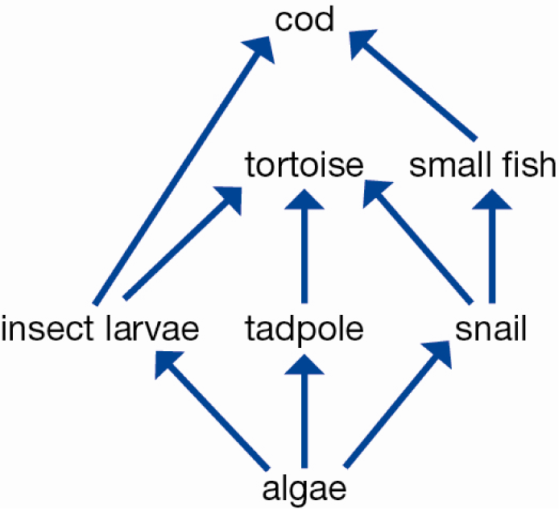  a Explain what the arrow between two organisms means.  b Identify the very important group of organisms that has not been included in this food web.  c Explain the role of this group of organisms.  d Identify and record two different food chains that include the tortoise.  e Explain why this community could not survive without the algae. | a The arrow between two organisms represents the direction of energy flow. A → B implies that B consumes A and obtains energy and matter from it.  b The decomposers have been left out of this food web.  c They feed on the dead remains of plants and animals and their wastes. They are important because they break this matter down and return many useful substances to the environment.  d algae → tadpole → tortoise → cod  algae → insect larvae → tortoise → cod  algae → snail → tortoise → cod  e Algae are the only producer organisms in the community, and therefore all the consumers rely directly or indirectly on them for food. | 5
 | Interpret the food web then identify the organisms that are third-order consumers.  A Silver perch, trout, pelican  B Kingfisher, daphnia, trout  C Silver perch, tadpole, duck  D Pelican, duck, daphnia | A | 1

